**Assignment 05: Assignment and practice of AI Image Generator.**

# **Assignment Tasks**

## **Task 1: Comparative Research**

**Image Of Midjourney:'A steampunk city under moonlight with flying airships and glowing lanterns.'**

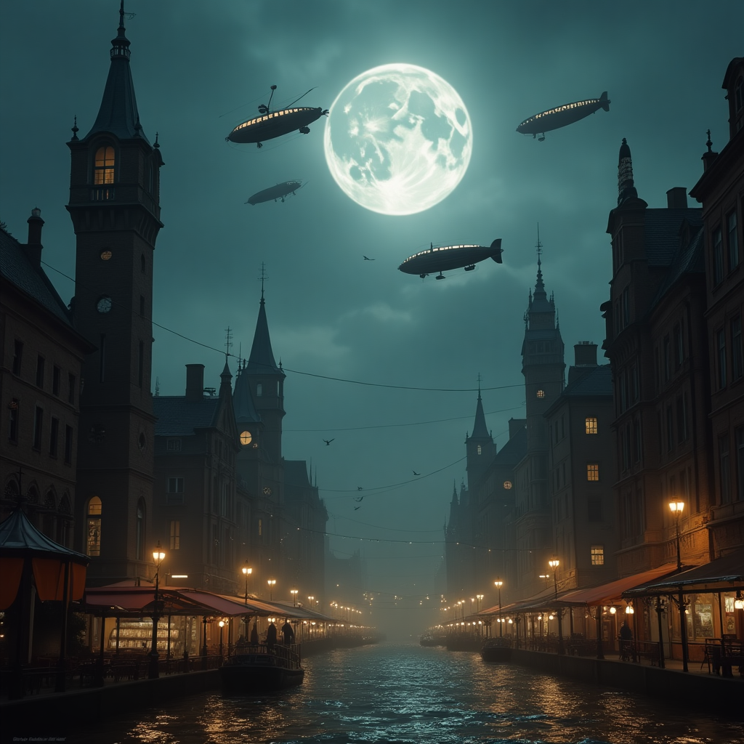

1. **Image Quality:**

Known for a painterly, cinematic, highly stylized output—fantasy-rich, detailed, and visually emotive. It’s often described as “dreamlike,” "artistic," or “concept art quality”

1. **Prompt Accuracy:**

Takes a more creative, interpretive approach. It prioritizes style and artistic mood over rigid accuracy—often adding unexpected textures or dramatic lighting.

1. **Style Flexibility:**

Offers deep style control via parameters—like --ar (aspect ratio), --stylize, or Discord-specific remix and variation features. Plus, the newer web UI provides visual editing tools like zoom, pan, and inpainting.

1. **Usability:**

Operates through Discord (though a web UI exists now). You generate images using commands like /imagine and control settings with specific modifiers. This gives power—but comes with a learning curve. Its setup process can feel overwhelming for newcomers.

1. **Licensing & Terms:**

On a paid plan, you own your creations and can use them commercially. Free users, however, are limited to personal or non-commercial use only. Plus, Midjourney's public galleries mean your images may be shown—unless you're on a private plan.

**Image Of DALL-E:'A steampunk city under moonlight with flying airships and glowing lanterns.'**

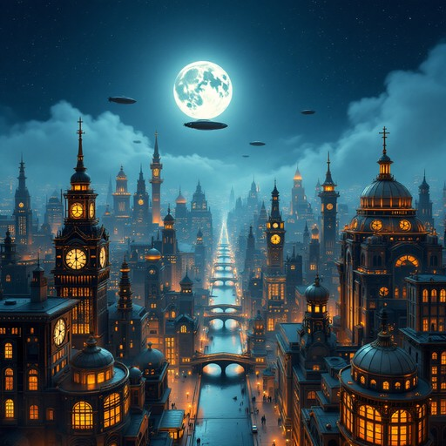

**1. Image Quality:**

More realistic, cleaner, and precise—especially strong for photorealistic or illustrative visuals. It adheres to prompt details carefully, with tighter control over representational fidelity .

**2.** **Prompt Accuracy:**

Excels in interpreting prompts literally. It ensures each element you mention is strongly represented—and it can even embed readable text (like signs or labels) accurately.

**3. Style Flexibility:**

While prompt-rich in natural language, it lacks mid-generation fine-tuning tools. However, the integration with ChatGPT allows you to refine through conversation (e.g., “make the lanterns glow brighter”) and leverage inpainting/outpainting for edits.

**4.** **Usability:**

Very beginner-friendly—just type your prompt into ChatGPT (Plus) or Bing's Image Creator. Conversation-based refinement lets you adjust easily.

**5.** **Licensing & Terms:**

Users own the images they generate—including the right to reprint, sell, and merchandise them—regardless of using free or paid credits.

## **Task 2: Visual Design Project**

## **Design a visual story using 3 image prompts**

**Visual Story: “The Lost Astronaut”:**

**Prompt 1:**

A lone astronaut floats in deep space, far from Earth. Stars glitter around him, and the faint glow of a shattered space station drifts in the distance. His suit lights flicker, emphasizing his isolation.

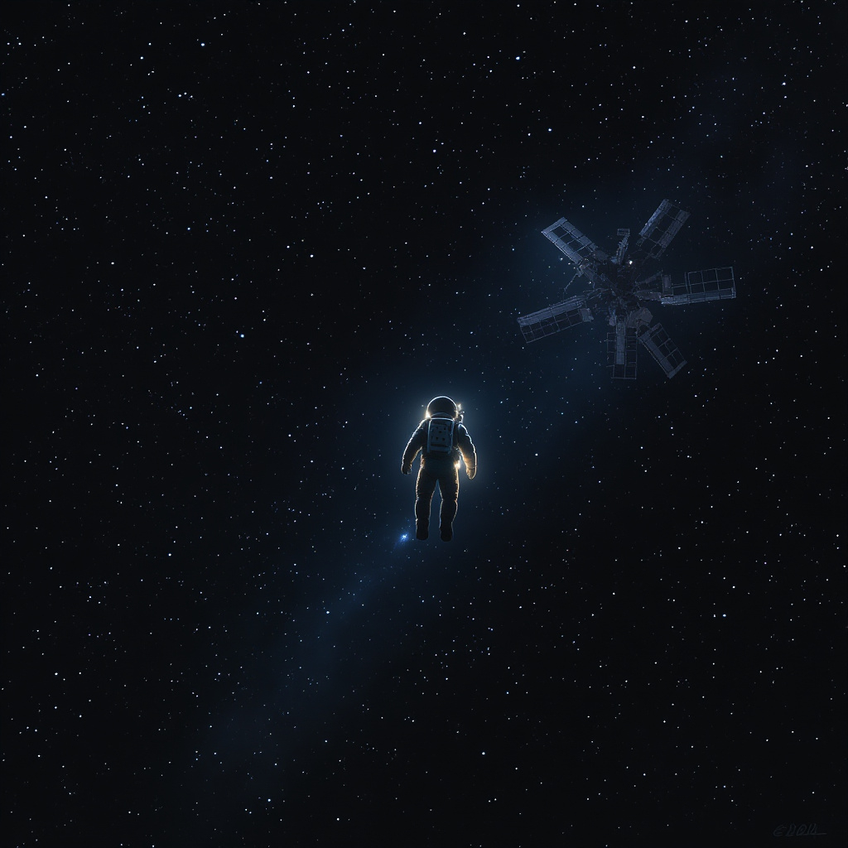

**Prompt 2:**

The astronaut approaches a colossal alien structure floating in space — a glowing, geometric monolith radiating colors unseen on Earth. Its surface pulses with energy as the astronaut reaches out a trembling hand.

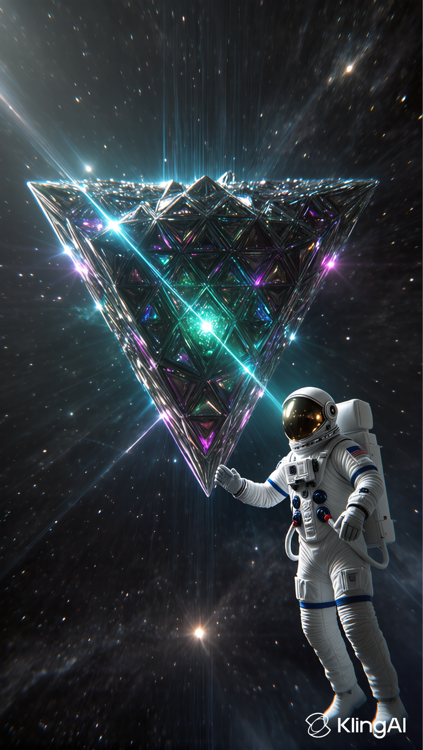

**Prompt 3:**

The astronaut is engulfed in radiant light as the alien structure awakens. His body begins to dissolve into streams of glowing stardust, merging with the cosmic energy, becoming part of the universe itself.

